

**Faculty of Engineering & Technology Electrical & Computer Engineering Department**

**Computer Networks Laboratory – ENCS4130 Report#1**

**Exp. NO. 4: Dynamic Routing 2 (Link State Routing Protocols) Open Shortest Path First (OSPF)**

**Prepared by:** Mohammad Salem 1200651

**Instructor:** Dr. Abdalkarim Awad

**Teacher Assistant:** Eng. Katy Sadi

**Section: 6**

**Date:** 30-3-2024

## Abstract

The experiment aims to grasp the intricacies of IP routing configuration using Cisco routers and specifically focus on the Open Shortest Path First (OSPF) protocol, a pivotal Link State Routing Protocol. Through Packet Tracer software simulations, participants learn to practically configure OSPF within network topologies, covering router identifiers, network addresses, bandwidth values, loopback IPs, Router ID, and route summarization.

These exercises underscore the significance of dynamic routing protocols like OSPF in optimizing data transmission across complex networks.

# Table of Contents

1. Theory 1
   1. Introduction 1
   2. What is OSPF? 2
   3. OSPF Features 3
   4. Route Summarization 3
   5. Routing Hierarchy 3
   6. Router ID 4
2. Procedure 5
   1. Building the Topology 5
      1. Configuring IPs for the Routers 7
      2. Configuring IPs for the PCs 9
      3. Configuring Loopback Ips for Router 2 9
   2. Configuring OSPF Routing 10
      1. Configuring OSPF on Router 0 11
      2. Configuring OSPF on Router 1 11
      3. Configuring OSPF on Router 2 11
      4. Configuring OSPF on Router 3 11
   3. Changing the Cost 12
   4. Summarization 13
3. Results 14
   1. Routers Interfaces 14
   2. OSPF Routing Configurations 16
   3. Tracing the Route between PC0 and PC4 17
4. Conclusion 19
5. Feedback 20
6. References 21

**Acronyms and Abbreviations**

|  |  |
| --- | --- |
| OSPF | Open Shortest Path First |
| SPF | Shortest Path First |
| BGP | Border Gateway Protocol |
| IGP | Interior Gateway Protocol |
| VLSM | Variable Length Subnet Mask |
| AS | Autonomous System |
| LSAs | Link State Advertisements |
| ABR | Area Border Router |

# List of Figures

Figure 1: Routing Protocols Types 1

Figure 2:OSPF 2

Figure 3: Routing Hierarchy Example 4

Figure 4: Routing Hierarchy Example 5

Figure 5: PC1 IP Address Configurations 9

Figure 6 : Ports’ Information for Router2 10

Figure 7: Router 0 Interfaces Configurations 14

Figure 8: Router 1 Interfaces Configurations 14

Figure 9 : Router 2 Interfaces Configurations 14

Figure 10:Router 3 Interfaces Configurations 14

Figure 11: Router 0 OSPF Configurations 15

Figure 12: Router 1 OSPF Configurations 15

Figure 13: Router 2 OSPF Configurations 15

Figure 14: Router 3 OSPF Configurations 15

Figure 15: Route from PC0 to PC4 – Before Changing Cost 17

Figure 16: Route from PC0 to PC4 – After Changing Cost 18

**List of Tables**

Table 1: Topology Components IP addresses 5

# Theory

## Introduction

Routing involves determining the most efficient paths for data packets to reach their intended destinations. This process includes constructing a routing table that holds information about these packet routes. Devices at the network layer execute routing, selecting optimal routes between networks. There exist three primary types of routing: Static, Dynamic, and Default Routing. Static routing involves manually adding networks and routes to the routing tables.[1]

Default Routing directs all packets to a single router (next hop). Dynamic routing, on the other hand, automatically adjusts routes in real-time within the routing table. Protocols employed in dynamic routing enable the discovery of paths to destinations and the selection of the most optimal routes. Notably, among the recommended dynamic routing protocols for implementation are RIP and OSPF..[2]

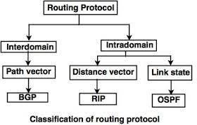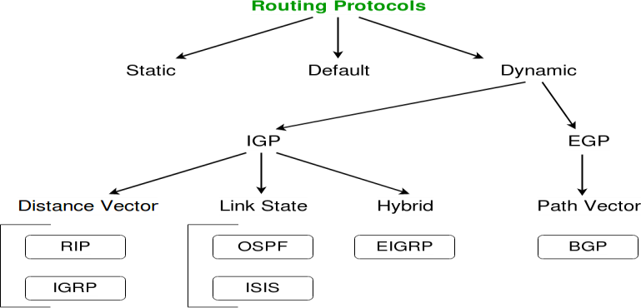

*Figure 1: Routing Protocols Types*

## What is OSPF?

The Open Shortest Path First (OSPF) protocol is an Interior Gateway Protocol (IGP) used on the Internet to distribute IP routing tables throughout a single Autonomous System (AS) on an IP network. It is part of a series of routing protocols designed for this purpose.[3]

The Open Shortest Path First (OSPF) link-state routing protocol uses its own shortest path first (SPF) algorithm to determine the optimum route between the source and the goal router. In contrast to the distance-vector routing protocol, which exchanges the routing table periodically, the link- state routing protocol employs the idea of triggered updates, where updates are only made when changes are noticed in the learnt routing table.[4]

The Internet Engineering Task Force (IETF) designed Open Shortest Path First (OSPF) to be part of the Interior Gateway Protocols (IGP), i.e., the protocol that tries to move packets inside a routing domain or wide autonomous system.[4]

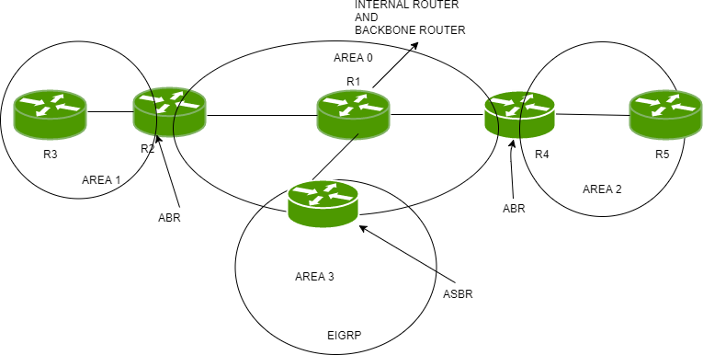

*Figure 2:OSPF*

## OSPF Features

OSPF, known for its versatility, provides several advantages. It supports both IPv4 and IPv6 as a classless protocol, offering flexibility in addressing. One of its strengths lies in load balancing for equally costed routes and the absence of limitations on the number of hops, ensuring scalability and efficient routing. Additionally, OSPF boasts widespread compatibility among routers, making it a widely accepted and accessible protocol within networking infrastructures.

## Route Summarization

Route summarization, alternatively termed as route super-netting or aggregation, is a technique that consolidates multiple networks or subnets into a single summary route [6]. This approach yields various benefits:

* Memory efficiency is enhanced as the condensed routing tables consume less memory [7].
* Bandwidth conservation occurs due to fewer paths being advertised [7].
* CPU cycles are preserved as there are fewer packets to analyze and smaller routing tables to manage [7].
* Stability is promoted by preventing erratic networks from inducing instability in routing tables [7].

## Routing Hierarchy

In both the Link State and Distance Vector algorithms, every router is required to maintain fundamental information about all other routers within the network. With network expansion, the number of routers also increases, leading to larger routing tables. Consequently, managing network traffic becomes less efficient as routing tables grow in size. Hierarchical routing presents a solution to address this issue [8].

Hierarchical routing organizes routers into distinct regions or areas. Within its designated area, each router possesses precise information on how to forward packets to their intended destinations. However, routers lack awareness regarding the internal structure of other areas [8].

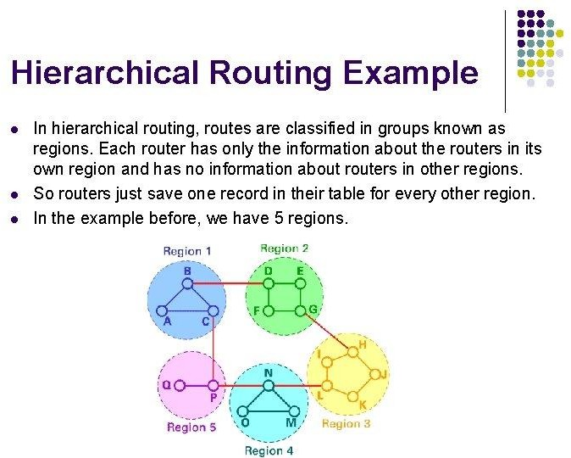

*Figure 3: Routing Hierarchy Example*

## Router ID

The OSPF router ID serves as a unique identifier for establishing connections with OSPF neighbors and is represented by an IP address. By default, during startup, the highest physical interface's IP address is chosen as the router ID. However, loopback interfaces hold superiority over physical interfaces in this regard [9].

To manually set the router ID value, the command used is:

**Router(config-router) #router-id <A.B.C.D>**

# Procedure

## Building the Topology

Using Packet Tracer, the depicted topology in figure 3 was constructed. This network layout encompasses an Autonomous System (AS) divided into three discrete areas. Across these areas, there are a total of seven networks. The primary area, Area 0, encompasses networks 0, 1, 2, and

3. Area 1 includes network 4 and six loopback networks configured on Router 2, serving as the connection between Area 1 and Area 0. Area 2 comprises Network 5 and links to Area 0 through Router 3. Lastly, Area 3 hosts Network 6 and connects to Area 0 via Router 0.

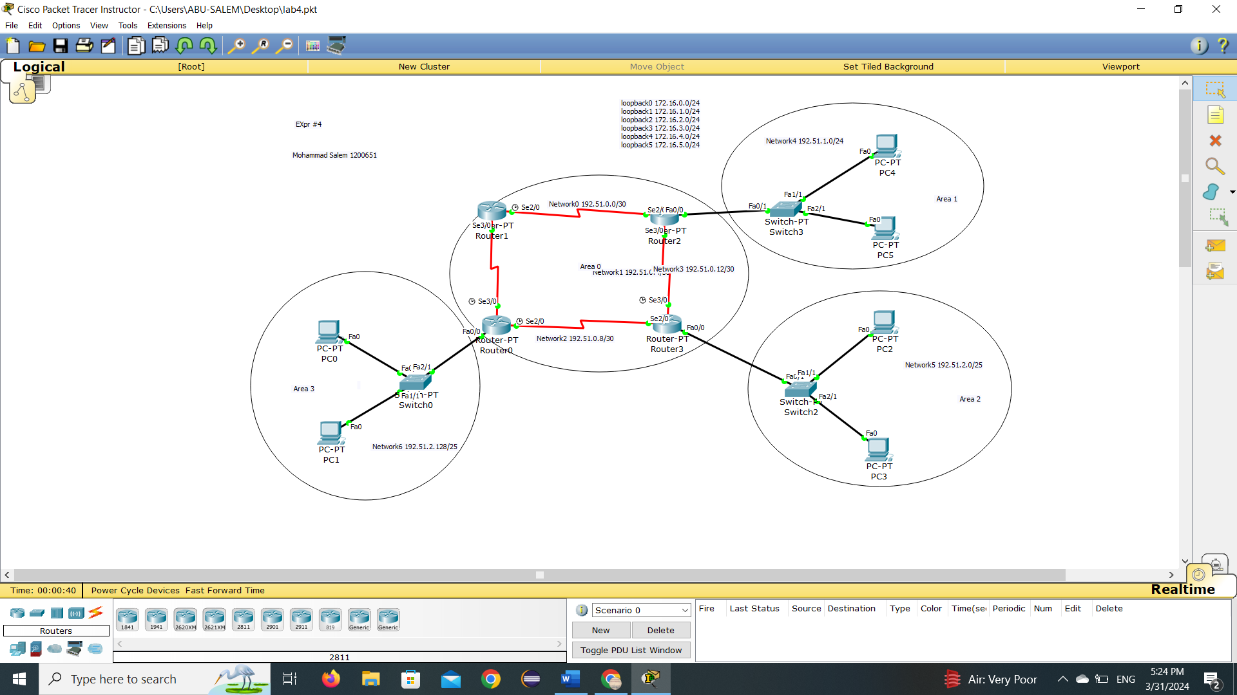

*Figure 4: Routing Hierarchy Example*

After building the topology, the IP addresses for both PCs and routers were set based on table 1 shown below.

*Table 1: Topology Components IP addresses*

|  |  |  |  |  |  |  |
| --- | --- | --- | --- | --- | --- | --- |
| **Area/ Summarization** | **Network** | **Device** | **Inter-face** | **IP** | **Subnet Mask** | **Wildcar dMask** |
| **Area 0** | Network 0 192.51.0.0/30 | Router 2 | Se2/0 | 192.51.0.1 | 255.255.255.252 | 0.0.0.3 |
| Router 1 | Se2/0 | 192. 51.0.2 | 255.255.255.252 | 0.0.0.3 |
| Network 1 192.51.0.4/30 | Router 0 | Se3/0 | 192. 51.0.5 | 255.255.255.252 | 0.0.0.3 |
| Router 1 | Se3/0 | 192. 51.0.6 | 255.255.255.252 | 0.0.0.3 |
| Network 2 192.51.0.8/30 | Router 0 | Se2/0 | 192.51.0.9 | 255.255.255.252 | 0.0.0.3 |
| Router 3 | Se2/0 | 192. 51.0.10 | 255.255.255.252 | 0.0.0.3 |
| Network 3 192.51.0.12/30 | Router 2 | Se3/0 | 192. 51.0.13 | 255.255.255.252 | 0.0.0.3 |
| Router 3 | Se3/0 | 192.51.0.14 | 255.255.255.252 | 0.0.0.3 |
| **Area 1** | Network 4 192.51.1.0/24 | Router 3 | Fa0/0 | 192. 51.1.1 | 255.255.255.0 | 0.0.0.255 |
| PC4 | Fa0 | 192. 51.1.2 | 255.255.255.0 | 0.0.0.255 |
| PC5 | Fa0 | 192. 51.1.3 | 255.255.255.0 | 0.0.0.255 |
| **Area 2** | Network 5 192.51.2.0/25 | Router 3 | Fa0/0 | 192.51.2.1 | 255.255.255.128 | 0.0.0.127 |
| PC2 | Fa0 | 192. 51.2.2 | 255.255.255.128 | 0.0.0.127 |
| PC3 | Fa0 | 192. 51.2.3 | 255.255.255.128 | 0.0.0.127 |
| **Area 3** | Network 6 192.51.2.128/25 | Router 0 | Fa0/0 | 192.51.2.129 | 255.255.255.128 | 0.0.0.127 |
| PC0 | Fa0 | 192.51.2.130 | 255.255.255.128 | 0.0.0.127 |
| PC1 | Fa0 | 192.51.2.131 | 255.255.255.128 | 0.0.0.127 |
| **Summarization 172.16.0.0/22** | 172.16.0.0/24 | Router2 | Loopback0 | 172.16.0.1 | 255.255.255.0 | 0.0.0.255 |
| 172.16.1.0/24 | Router2 | Loopback1 | 172.16.1.1 | 255.255.255.0 | 0.0.0.255 |
| 172.16.2.0/24 | Router2 | Loopback2 | 172.16.2.1 | 255.255.255.0 | 0.0.0.255 |
| 172.16.3.0/24 | Router2 | Loopback3 | 172.16.3.1 | 255.255.255.0 | 0.0.0.255 |
| **Summarization 172.16.4.0/23** | 172.16.4.0/24 | Router2 | Loopback4 | 172.16.4.1 | 255.255.255.0 | 0.0.0.255 |
| 172.16.5.0/24 | Router2 | Loopback5 | 172.16.5.1 | 255.255.255.0 | 0.0.0.255 |

### Configuring IPs for the Routers

To access the configuration dialogue for each router, you need to open the CLI tab and type "no" to enter user execution mode. From there, you can switch to privilege mode by using the "enable" command. Once in privilege mode, you can modify the running-configurations of the router by typing "config t." The process is outlined below:

Continue with configuration dialog? [yes/no]: no Press RETURN to get started!

Router> enable Router# config t

Enter configuration commands, one per line. End with CNTL/Z. Router(config)#

After that, the status of each interface was changed to "up," and its IP address was configured using the following commands:

Router(config)# interface <TYPE> <SLOT>/<PORT> Router(config-if) # no shutdown

%LINK-5-CHANGED: Interface <TYPE> <SLOT>/<PORT>, changed state to up

%LINEPROTO-5-UPDOWN: Line protocol on Interface <TYPE> <SLOT>/<PORT>, changed state to up

Router(config-if) # ip address <IP-ADDRESS> <SUBNET-MASK>

Where the words enclosed by < > are replaced by their corresponding values.

The loopback interfaces were created and configured in a similar way, except that the interface is up by default, hence, no need to us the “no shutdown” command.

Router(config)# interface loopback <LOOPBACK_NUM>

%LINK-5-CHANGED: Interface Loopback<LOOPBACK_NUM>, changed state to up

%LINEPROTO-5-UPDOWN: Line protocol on Interface Loopback <LOOPBACK_NUM>, changed state to up

Router(config-if) #ip address <IP-ADDRESS> <SUBNET-MASK>

Finally, to exit an interface configuration and go back to the configuration command line, “exit” command was used.

For example, Router 0 IP address was set by using these commands which is written in CLI:

* **Router(config)#interface Serial2/0**
* **Router(config-if) #ip address 192.51.0.9 255.255.255.252**
* **Router(config-if) #exit**
* **Router(config)#interface Serial3/0**
* **Router(config-if) #ip address 192.51.0.5 255.255.255.252**

### Configuring IPs for the PCs

The IP addresses for PC 1 were configured through the IP Configuration app on the desktop. As depicted in figure 4, the settings aligned with the values specified in table 2.1. Additionally, to establish the default gateway, PC 1's settings were aligned with the address of the router's interface situated within the same network as the PC.

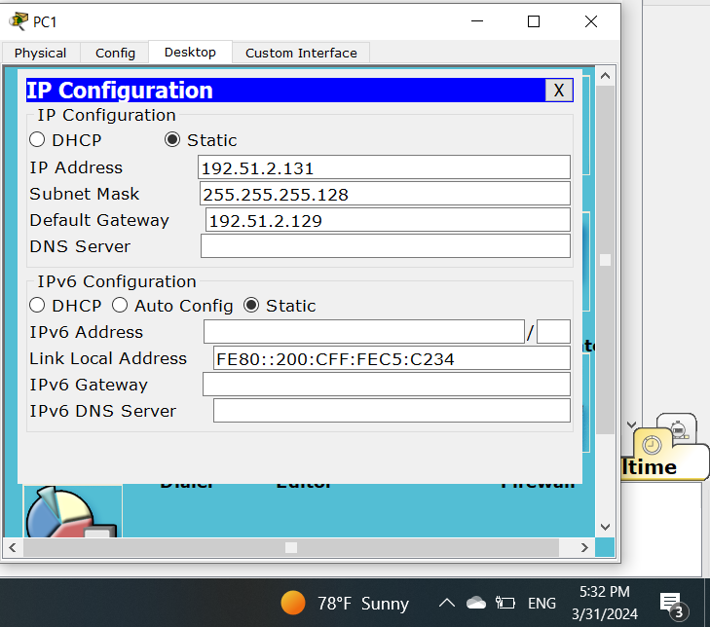

Figure 5: *PC1 IP Address Configurations*

### Configuring Loopback Ips for Router 2

Loopback IPs were configured using these commands:

* + - * Router(config)#interface loopback 0
      * Router(config-if) #ip address 172.16.0.1 255.255.255.0

In the following picture, we can see the ports’ information for router2:

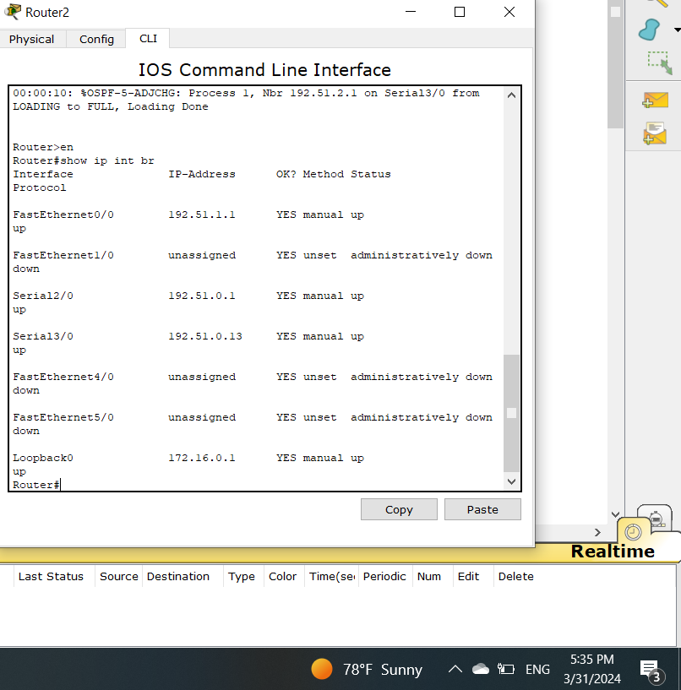

*Figure 6 : Ports’ Information for Router2*

### Configuring OSPF Routing

Upon configuring the IP addresses for both routers and PCs, OSPF protocol implementation was carried out across all routers. Due to the network's division into various areas, the area numbers assigned to interfaces might vary. Each router autonomously advertises all networks directly connected to it within the OSPF framework. For each router, OSPF was configured using the following command:

Router(config)#router ospf <PROCCESS-ID>

Where the Process ID can take an integer value between 1 and 65535. However, in our topology, the Process ID was set to 1 for all routers.

After executing the previous command, the networks that are directly connected to the router’s interfaces were added to be used in OSPF routing. This was done using the following command:

Router(config-router) #network <NETWORK-ID> <OSPF-WILDCARD-BITS> area

<AREA-ID>

### Configuring OSPF on Router 0

Router(config)#router ospf 1

Router(config-router) #network 192.51.0.4 0.0.0.3 area 0

Router(config-router) #network 192.51.0.8 0.0.0.3 area 0

Router(config-router) #network 192.51.2.128 0.0.0.127 area 3

### Configuring OSPF on Router 1

|  |  |  |  |  |
| --- | --- | --- | --- | --- |
| Router(config)#router ospf 1 |  |  |  |  |
| Router(config-router)#network | 192.51.0.0 | 0.0.0.3 | area | 0 |
| Router(config-router)#network | 192.51.0.4 | 0.0.0.3 | area | 0 |

### Configuring OSPF on Router 2

Router(config)#router ospf 1

Router(config-router)#network 192.51.0.0 0.0.0.3 area 0

Router(config-router)#network 192.51.0.12 0.0.0.3 area 0

Router(config-router)#network 192.51.1.0 0.0.0.255 area 1

The addition of loopback networks followed the same process as the previous networks. However, their configurations will be discussed later in the summarization section, as route summarization was employed.

### Configuring OSPF on Router 3

Router(config)#router ospf 1

Router(config-router)#network 192.51.0.8 0.0.0.3 area 0

Router(config-router)#network 192.51.0.12 0.0.0.3 area 0

Router(config-router)#network 192.51.2.0 0.0.0.127 area 2

## Changing the Cost

In order to make the packets from PC0 go to PC4 by the route R0 → R3 → R2 instead of R0 → R1→ R2, the cost was changed from 1 (which was set by default) to 5. which mean that the bandwidth was set to 20000Kbits using the formula:

**New Bandwidth =** 𝟏𝟎𝟎𝑴𝒃**/**𝑪𝒐𝒔**t**

To modify the cost of an interface, you can use the following command within the interface configuration:

**Router(config-if) #bandwidth <BANDWIDTH-IN-KILOBITS>**

Using this command, the bandwidth of se2/0 interface of router 0 was changed to 20000, reducing the cost from 781 to 5.

Router(config)#interface se2/0 Router(config-if)#bandwidth 20000

## Summarization

The loopback networks were added to OSPF routing table by using these commands:

* + - Router(config)#router ospf 1
    - Router(config-router)#network 172.51.0.0 0.0.3.255 area 1
    - Router(config-router)#network 172.51.4.0 0.0.1.255 area

These commands are summarized from these commands:

* Router(config)#router ospf 1
* Router(config-router) #network 172.51.0.0 0.0.0.255 area 1
* Router(config-router) #network 172.51.1.0 0.0.0.255 area 1
* Router(config-router) #network 172.51.2.0 0.0.0.255 area 1
* Router(config-router) #network 172.51.3.0 0.0.0.255 area 1
* Router(config-router) #network 172.51.4.0 0.0.0.255 area 1
* Router(config-router) #network 172.51.5.0 0.0.0.255 area 1
  + 172.51.0.0/22 contains: 172.51.0.0/24, 172.51.1.0/24, 172.51.2.0/24, and 172.51.3.0/24.
  + 172.51.4.0/23 contains: 172.51.4.0/24, and 172.51.5.0.

Due to this, it is quite helpful to deal with only two networks and lessen CPU execution.

# Results

## Routers Interfaces

The configured interfaces in section 2.2.1 are verified using the following command

**sh ip int br(show ip interface brief)**

The command outputs for each router are shown in figure 3.1:

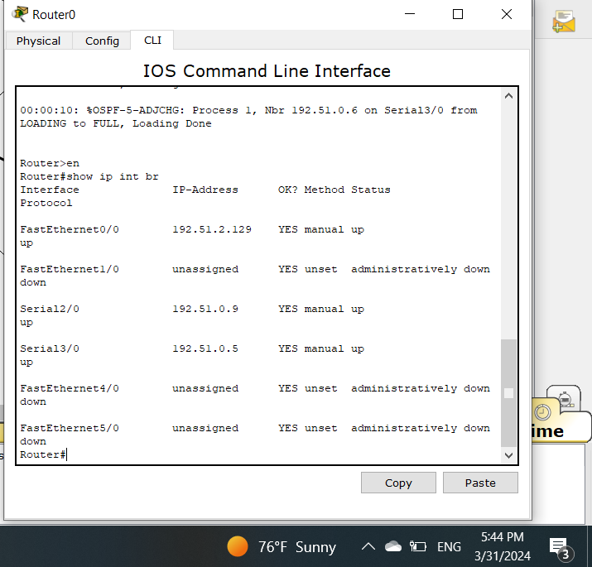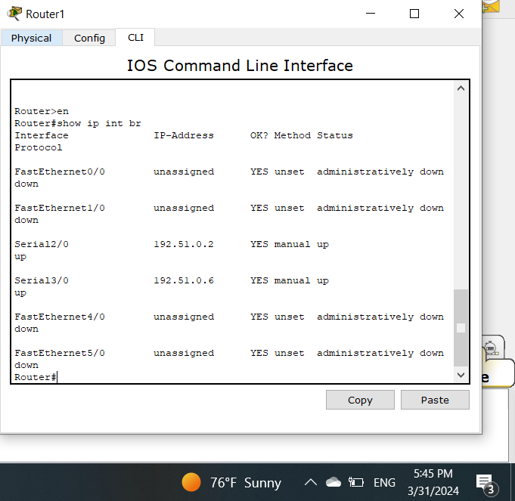

*Figure 7: Router 0 Interfaces Configurations Figure 8: Router 1 Interfaces Configurations*

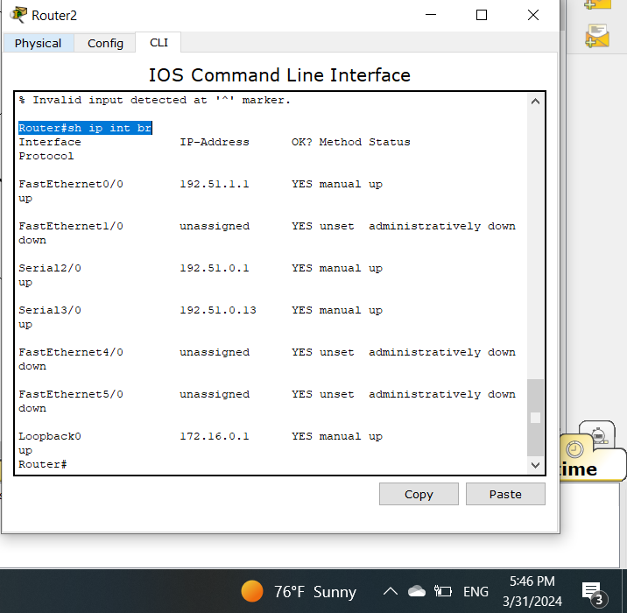 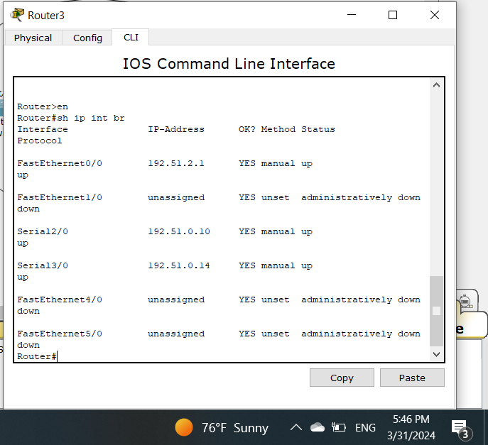

Figure 9:*Router 2 Interfaces*

*Configurations*

*Figure 10 : Router 3 Interfaces Configurations*

## OSPF Routing Configurations

OSPF routing configurations are shown using the following command:

**show ip protocol**

The command execution output for the routers 0, 1, 2, and 3 is shown in figure 8

|  |  |
| --- | --- |
| *Figure 7: Router 0 OSPF Configurations* | *Figure 8: Router 1 OSPF Configurations* |
| *Figure 9: Router 2 OSPF Configurations* | *Figure 10: Router 3 OSPF Configurations* |

## Tracing the Route between PC0 and PC4

The connection between PC0 and PC4 was examined on four separate occasions. The first two examinations were carried out using the standard bandwidth settings of the links. Following that, the remaining two examinations were conducted after increasing the bandwidth of the se2/0 interface on router 0 to 20000 kB, resulting in a reduced cost of 5. To determine the route, the "tracert" command was executed, and the target IP address (PC4's IP address) was inputted.

**Tracing Before Changing Cost**

Before changing the cost, the route was once through PC0→ Router0 → Router3 → Router2 → PC4, and the other was through PC0→ Router0 → Router1 → Router2 → PC4. This is because both routes have the same cost, and OSPF uses equal-cost multipath routing.

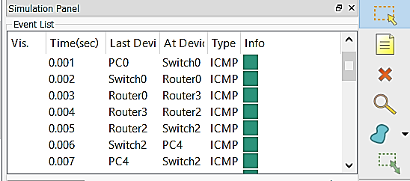

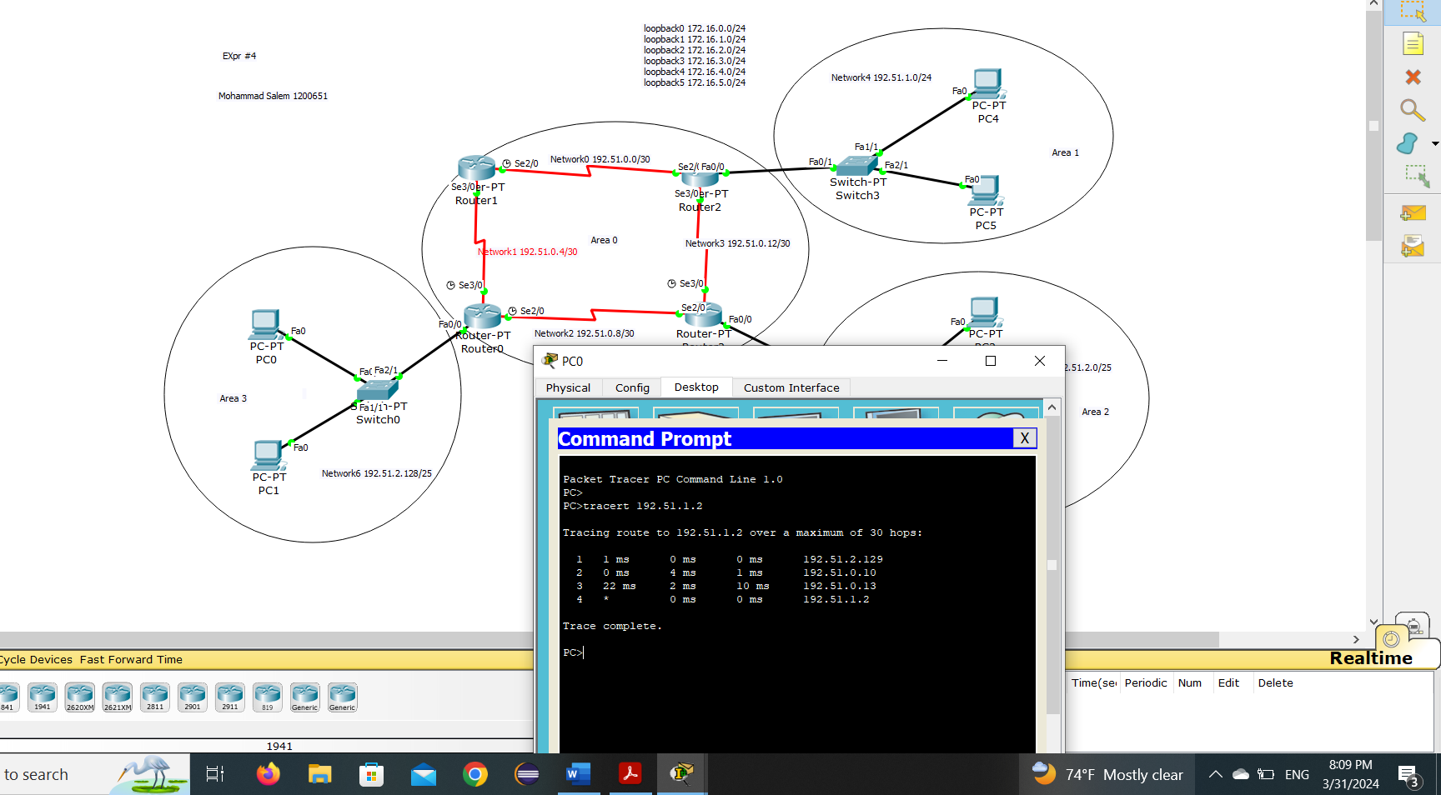

*Figure 11: Route from PC0 to PC4 – Before Changing Cost*

**Tracing After Changing Cost**

After changing the cost, the route PC0→ Router0 → Router1 → Router2 now have lower cost than PC0→ Router0 → Router3 → Router2, hence, the packets will always be routed through router 1, rather than router 3. This can be seen in figure 3.4 bellow

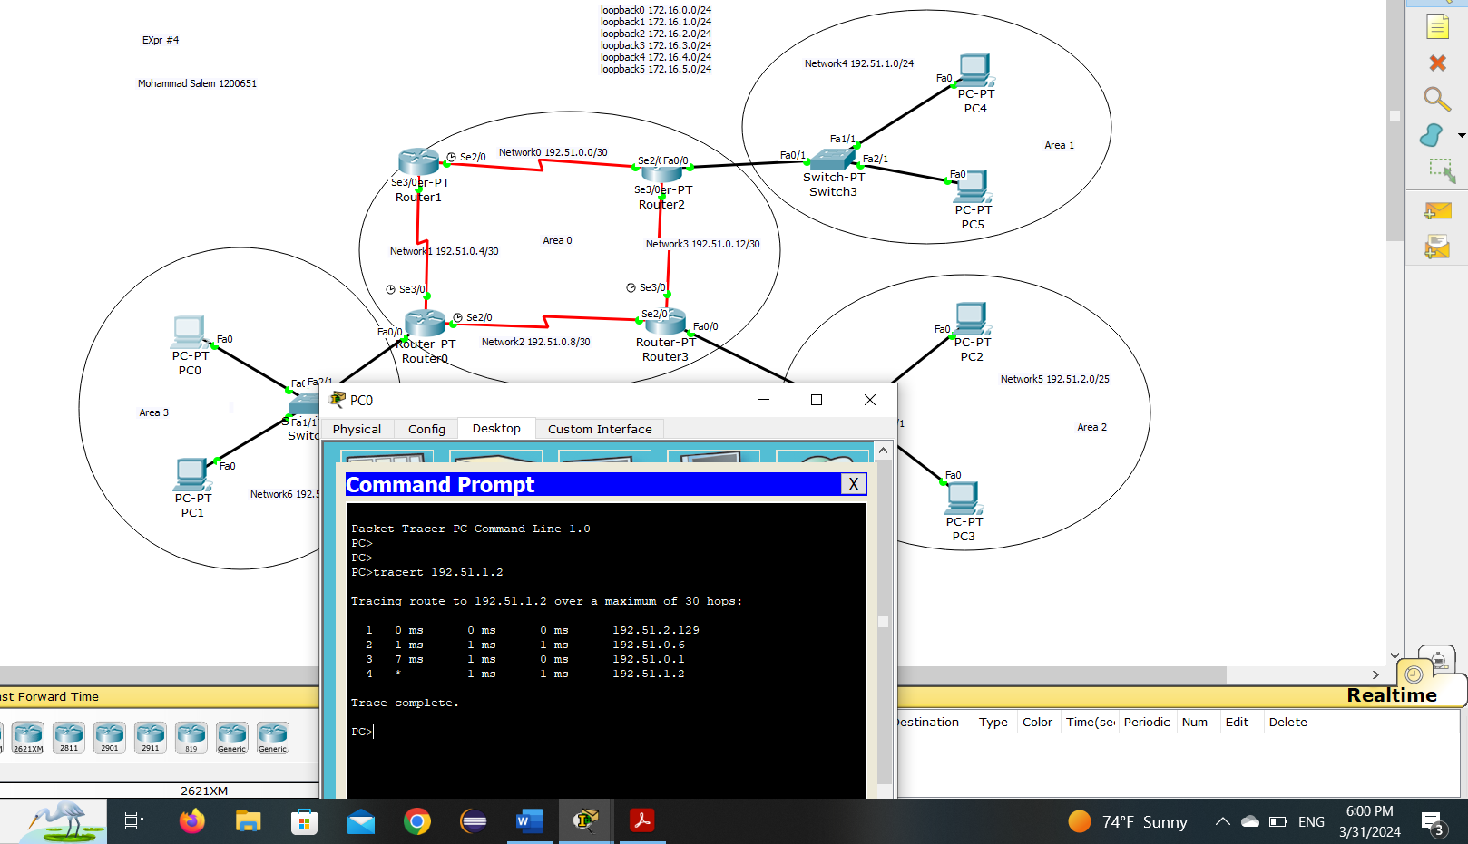

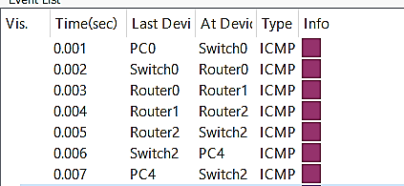

*Figure 12: Route from PC0 to PC4 – After Changing Cost*

*Figure 12: Route from PC0 to PC4 – After Changing Cost*

# Conclusion

Upon concluding the experiment, we delved into OSPF, a significant Link-State Routing Protocol, comprehending its configuration, cost alteration of links, and validation of its functionality within the Cisco Packet Tracer network. Furthermore, our exploration encompassed understanding loopbacks and summarizations, learning their application methods, and recognizing their significance in networking practices. The experiment proved to be immensely valuable and engaging, providing a thorough understanding of these networking concepts. We found the hands- on experience enjoyable and beneficial, contributing significantly to our learning. Moreover, the allotted time was adequate, allowing us to thoroughly explore and grasp the intricacies of the experiment.

# Feedback

The experiment was engaging and informative, offering a clear understanding of the concepts, also the time was suitable, so we finished it on time.

## References

1. <https://www.cloudflare.com/learning/network-layer/what-is-routing/>.
2. <https://www.geeksforgeeks.org/types-of-routing/> .
3. <https://www.metaswitch.com/knowledge-center/reference/what-is-open-shortest-path-first-ospf>.
4. <https://www.geeksforgeeks.org/open-shortest-path-first-ospf-protocol-states/> .
5. [https://techhub.hpe.com/eginfolib/networking/docs/switches/5980/5200-3923_l3-ip-](https://techhub.hpe.com/eginfolib/networking/docs/switches/5980/5200-3923_l3-ip-rtng_cg/content/499045282.htm) [rtng_cg/content/499045282.htm](https://techhub.hpe.com/eginfolib/networking/docs/switches/5980/5200-3923_l3-ip-rtng_cg/content/499045282.htm) .
6. <https://bradhedlund.com/2006/02/19/route-summarization-with-alternate-paths/>.
7. [Introduction to Route Summarization (networklessons.com)](https://networklessons.com/rip/introduction-route-summarization) .
8. [What is hierarchical routing (tutorialspoint.com)](https://www.tutorialspoint.com/what-is-hierarchical-routing) .